Emergency Contact
Full name:

Relationship: | Mobile:

Smoking Status
- Never Smoked | - Current Smoker (Please specify) | - Ex-Smoker
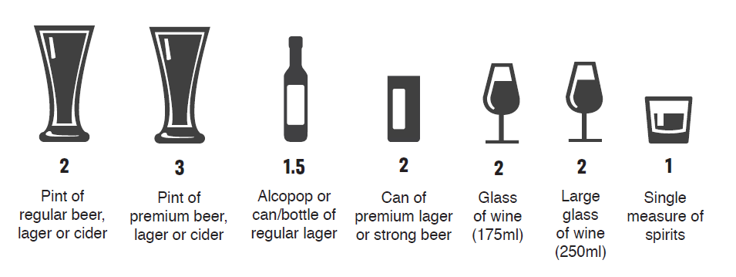

Alcohol Status
- No – I don’t drink alcohol | - Yes – I drink alcohol (units per week?)

Allergies
- No – I have no known allergies | - Yes – I have allergies (please specify)

Family History
- Cardiovascular | - Hypertension | - Asthma | - Cancer
- Diabetes Type 1 | - Diabetes Type 2 | - Lung Disease | - Sickle Cell
- Anaemia | - Mental Health | - Other | - No Family History
Please provide us with any significant health conditions you may have:

Please provide us with any mediation you are currently being prescribed:

Ethnicity
- White – British | - Mixed – White and Black African | - Black – British | - Asian – Indian
- White – Irish | - Mixed – White and Asian | - Black – African | - Asian – Pakistani
- White – Scottish | - Mixed – Any other Mixed background | - Black – Caribbean | - Asian – British
- Other (Specify):

Language
Main spoken language: | Will you require an interpreter?

Summary Care Record Sharing
Summary Care Records (SCR) – information for patients
- Summary
- Ask the doctor to include additional information on your SCR
- Protecting your SCR information
- Opting out
- More information on your health records
The information in your records can include your:
- Name, age and address
- Health conditions
- Treatments and medicines
- Allergies and past reactions to medications
- Test, scans and x-ray results
- Lifestyle information, such as whether you smoke or drink
- Hospital admission and discharge information

Find out about the types of records and how to access them

Please ask reception for a copy of the information regarding SCR and Opting out

- Express consent for medication, allergies, and adverse reactions only
- Express consent for medication, allergies, and adverse reactions, AND additional information
Signature: | Date:

Carers
Are you cared for by a friend or relative? | - Yes |  | - No
What is the relationship to the person who cares for you?
Are you a carer for a friend or relative? | - Yes |  | - No
What is the relationship to the person who you care for?
Signature: |  | Date:

